**What we have done last week:**

Map transformation is finished ([pice of the sample data](https://drive.google.com/drive/u/1/folders/1xQYEVKwL25PrxnNVX1Tcrd0O05oWnEfJ)).

The algorithm for different floors is finished.

Different solutions for mobile UI:

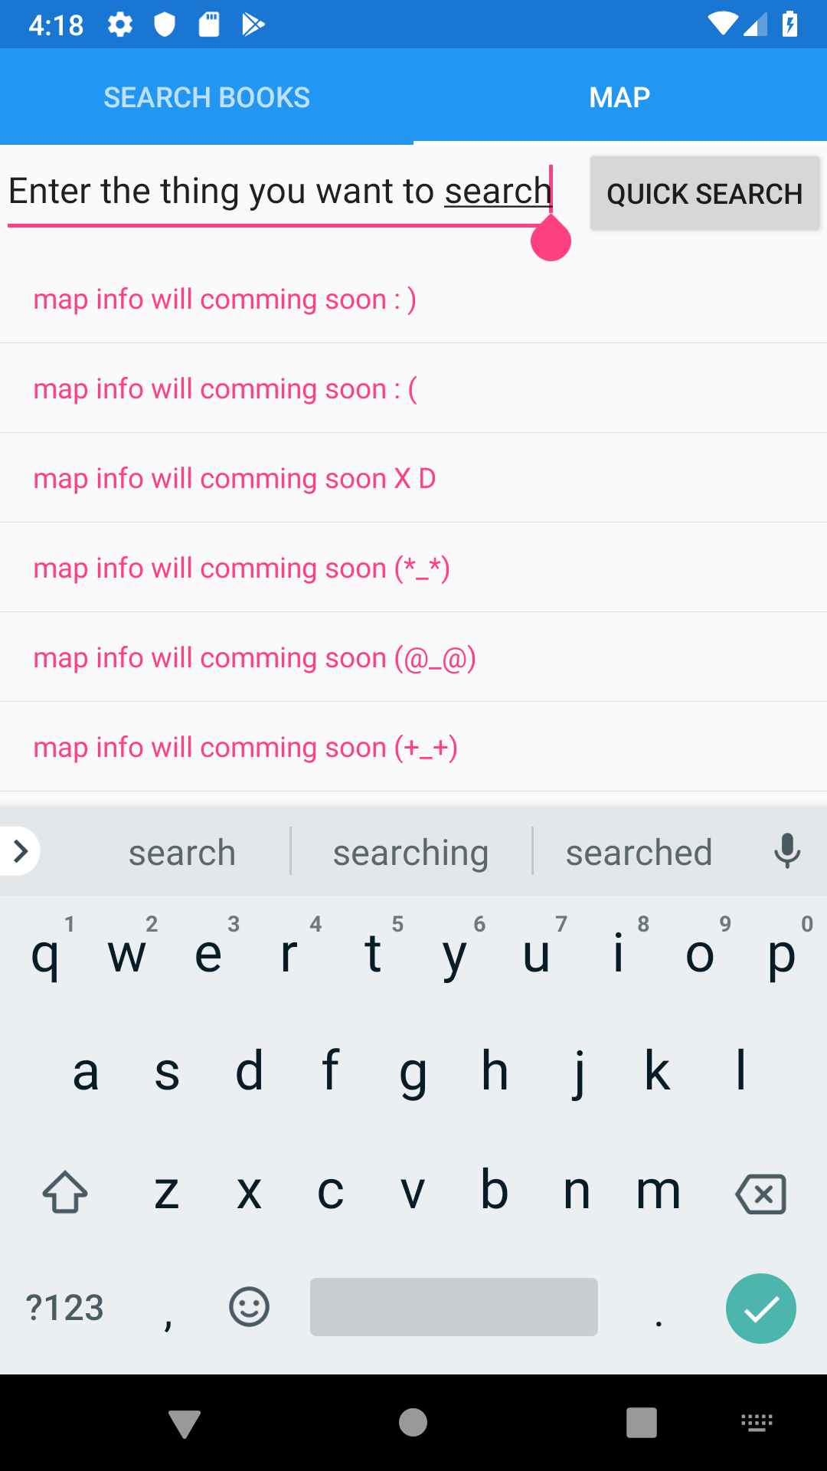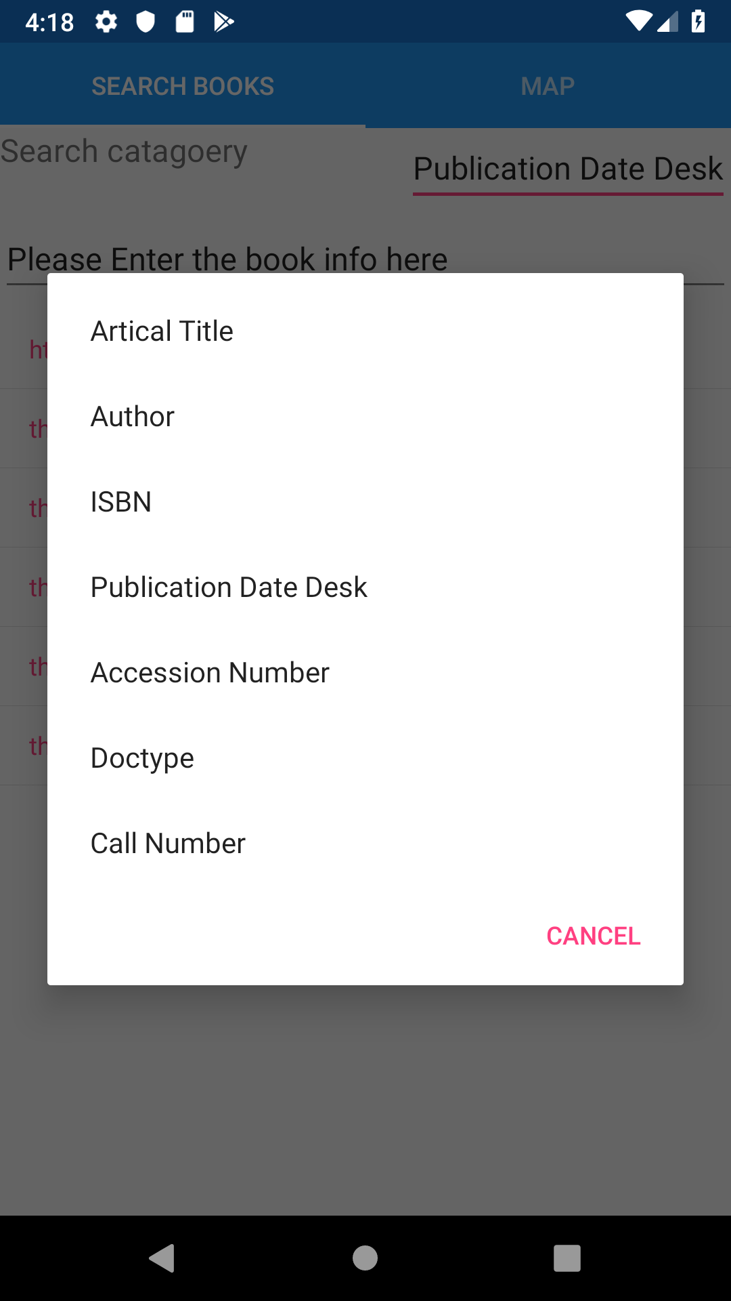

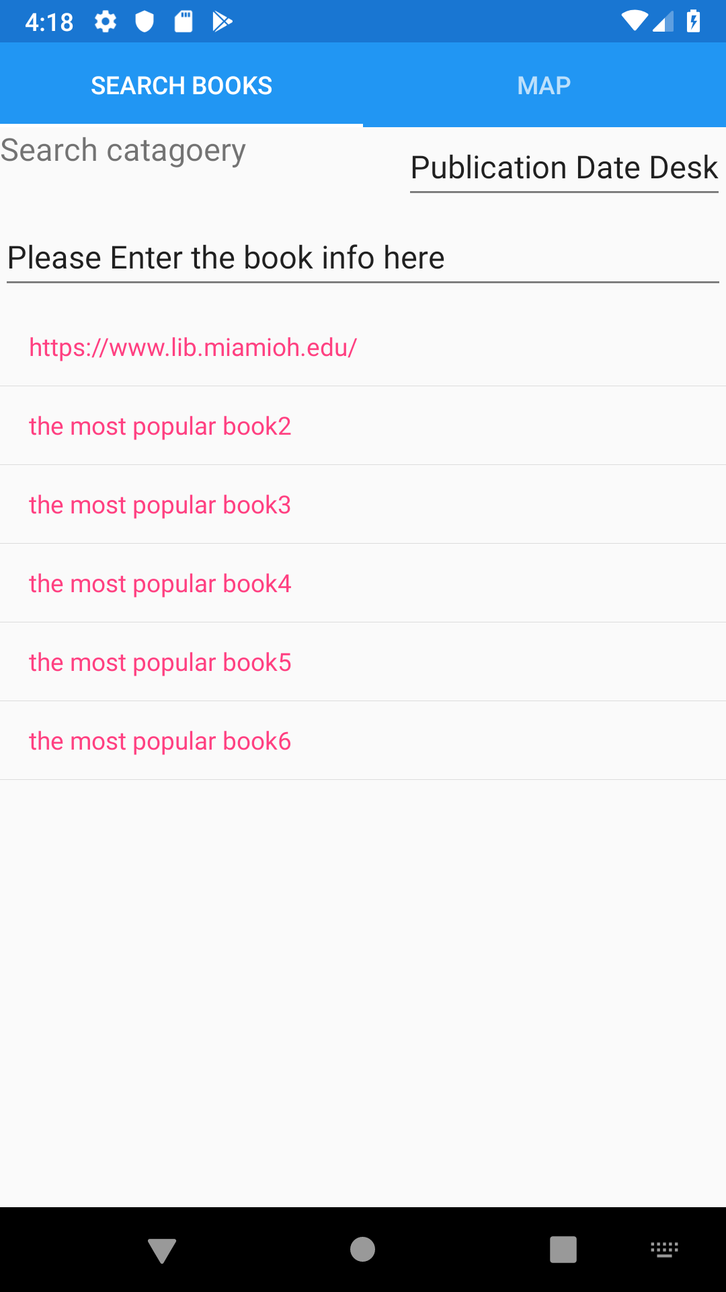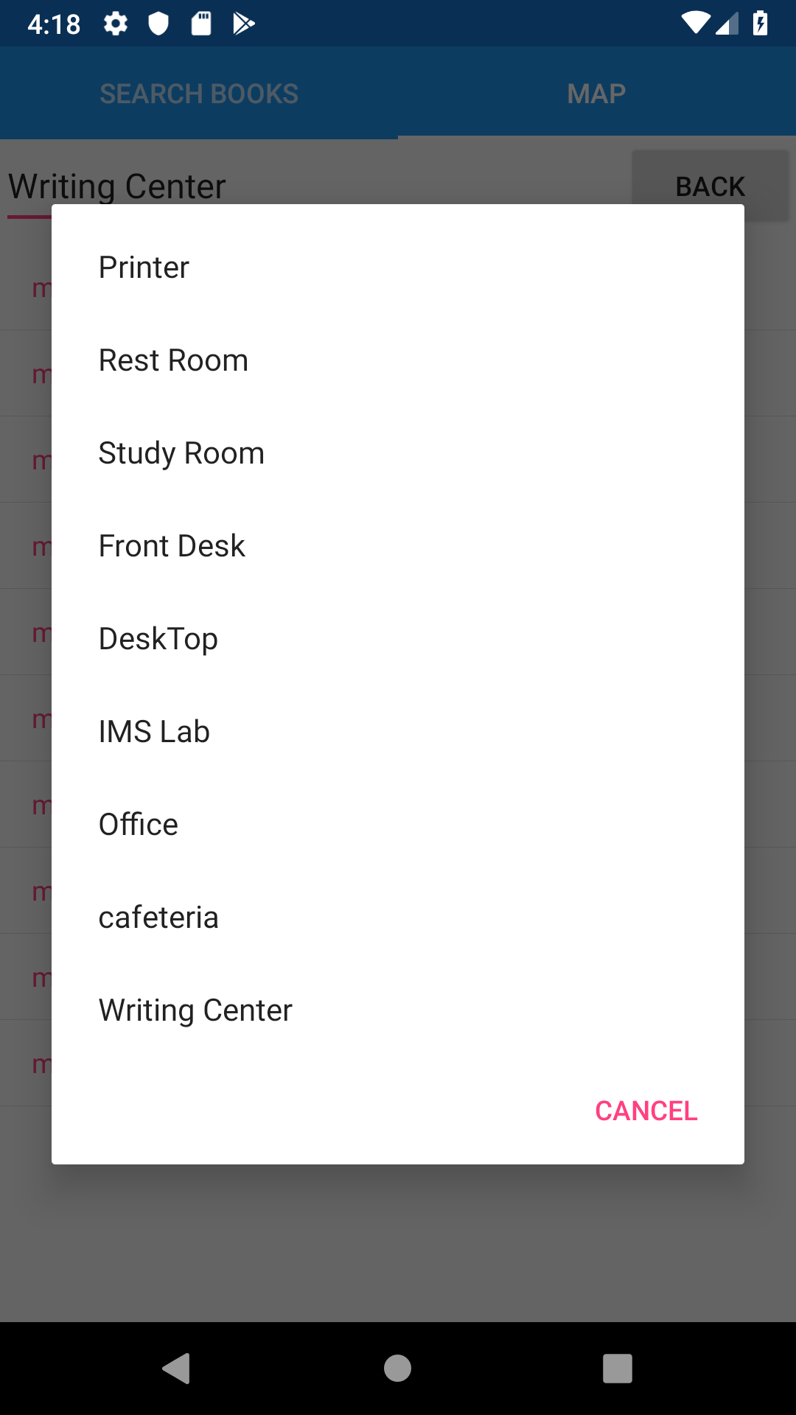

**The progress since the last week:**

Creating more mobile user interface demos for our clients to choose from.

Learning SQL lite.

**What will be starting next week:**

Testing of the algorithm (test all data from the grid map, test it and fix it if any error).

Adding basic functions to the App

Figure out how to draw a line based on the algorithm output

**Conclusion:**

Although the most app parts are not fully set up, we have data and algorithms already, so the remaining work might be heavy C# code, and more team members will join the app implementation.

**Meeting minutes:**

Demonstrate the way to map transformation by video or show directly to the groups during the next meeting(made by Weikai). Otherwise, everything is fine.